Insert your name, centre number and candidate number into the header above.
Save this evidence document as evidence_ followed by your centre number_ candidate number. For example: evidence_ zz999_9999
Screenshots or program listings must be copied into appropriate cells in the following tables.
Examiners must be able to read the contents including any screenshots without the use of a magnifying glass. Answers that are not readable or missing will not be awarded any marks.
Save this evidence document at regular intervals, for example, every 10 minutes.
Question 1
Part 1(a)
{#DECLARE StackData:ARRAY[0:9]OF INTEGER
global StackData
global StackPointer
StackData=[0]*10
StackPointer=0
}

Part 1(b)
{def Push(DataToPush):
global StackData
global StackPointer
if StackPointer==10:
return False
else:
StackData[StackPointer]=DataToPush
StackPointer=StackPointer+1
return True
}

Part 1(c)
{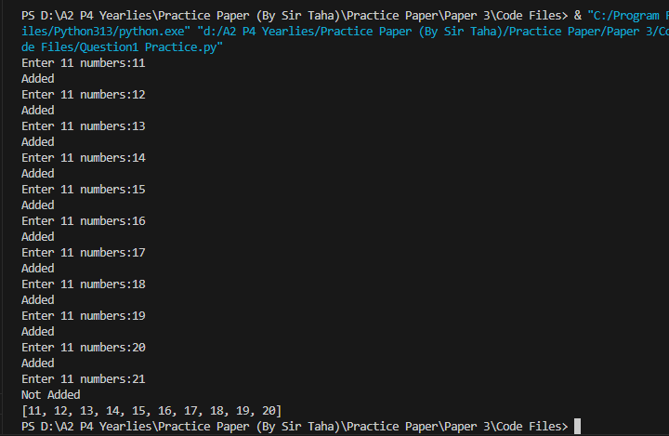 }

Part 1(d)(i)
{for x in range(11):
userinp=int(input("Enter 11 numbers:"))
Temp=Push(userinp)
if Temp==False:
print("Not Added")
else:
print("Added")
print(StackData)
}

Part 1(d)(ii)
{ }

Part 1(e)(i)
{def Pop():
global StackData
global StackPointer
if StackPointer==0:
return -1
else:
DataToReturn=StackData[StackPointer]
StackPointer=StackPointer-1
return DataToReturn
}

Part 1(e)(ii)
{Pop()
Pop()
print(StackData)
}

Question 2
Part 2(a)
{class QuestionClass():
#PRIVATE Question:STRING
#PRIVATE Answer:STRING
#PRIVATE Difficulty:INTEGER
def __init__(self,Question,Answer,Difficulty):
self.__Question=Question
self.__Answer=Answer
self.__Difficulty=Difficulty
}

Part 2(b)
{class Quiz():
#PRIVATE Questions:QuestionClass
#PRIVATE NumberOfQuestions:INTEGER
def __init__(self):
self.__Questions=[""]*20
self.__NumberOfQuestions=0
}

Part 2(c)
{ def AddQuestion(self,question):
if self.__NumberOfQuestions<20:
self.__Questions[self.__NumberOfQuestions]=question
self.__NumberOfQuestions=self.__NumberOfQuestions+1
return True
else:
return False
}

Part 2(d)
{Question1=QuestionClass("What is 100/5 ? :","20",1)
FirstQuiz=Quiz()
Temp=FirstQuiz.AddQuestion(Question1)
}
Question 3
Part 3(a)
{# DECLARE numData : ARRAY [0 : 9] OF INTEGER

numData = [10, 4, 23, 45, 12, 8, 21, 11, 3, 1]
}

Part 3(b)(i)
{#we can not take parameter by reference so that's why taken as global
def BubbleSort():
# DECLARE Noswaps : Boolean
# DECLARE y, temp : INTEGER
global numData
Noswaps = False
Boundary = 9
while Noswaps == False:
Noswaps = True
for y in range(Boundary):
if numData[y] > numData[y + 1]:
temp = numData[y]
numData[y] = numData[y + 1]
numData[y + 1] = temp
Noswaps = False
Boundary = Boundary - 1
}

Part 3(b)(ii)
{ }

Part 3(c)(i)
{def EvenNumber(Array):
count=0
for x in range(len(Array)):
if x%2==0:
count=count+1
return count
}

Part 3(c)(ii)
{Temp=EvenNumber(numData)
print("There are",Temp,"even numbers")
}

Part 3(c)(iii)
{ 

